**Patent report**

Title: “Design and fabrication of peel strength measuring machine”

**ABSTRACT:**

The project mainly focuses on measuring peel strength of adhesive tapes. Peel strength is average force required to separate two boded materials from one another, is properly applicable to various industries aerospace, automotive, adhesives, packaging, biomaterials, microelectronics, and more. Peel test data is used to determine the quality of the adhesive joint and, where applicable, provides information on the effects of processes. Peel tests are constant-speed tests in the tensile direction. In material testing, peel strength is calculated after measuring and averaging the load to peel the specimen and dividing the average load by unit width of the Adhesives. Different adhesives are used for joining the different types of materials. The different types of peel tests available for investigating the adhesive strength are 90º, 135º, 180º and T-peel test. This project mainly focuses on 180º peel type test.

Focal point of this study is to get precise reading by 180-degree peel strength measurement machine. in peel strength measuring machine that the motor which is low rpm drives power screw with help of coupler. rotating motion of leadscrew is converted into linear motion of table. Supporting bars support table mounted on leadscrew and adhesive strength tested with help of measuring gauge.

After successfully fabrication of peel strength measuring Machine results obtain are nearly equal to standard value or range of standard values given by manufacturer. Results obtain by testing machine for Sellotape is 0.1042 N/mm at room temperature and standard value given by manufacturer is 0.0374 N/mm , for surgical tape value at room temperature obtained is 0.4782 N/mm at room temperature and standard value is 0.345 N/mm , for masking tape value obtained at room temperature is 0.1658 N/mm at room temperature and standard value is 0.11104 N/mm, for wire insulation tape result at room temperature 0.1609 N/mm and standard value is 0.16, for double sided tape values obtained at room temperature is 1.4266 N/mm and standard value is 1.1042 N/mm.

180-degree peel strength measuring machine can measure adhesiveness of tape applied on any surface with higher accuracy. It requires zero lubrication and maintenance cost is also low. Machine is cheaper in cost and faster in working.

**DESCRIPTION:**

A project Peel Strength Measuring Machine is mainly focused on measuring the Peel strength of adhesive tapes. Peel strength is very important factor for any type of adhesive. Because it plays very important role for the selection of adhesive and as per the requirement parameter. Peel strength is generally used to measure the bond strength of a material, typically an adhesive. Peel strength is the average load per unit width of bond line required to separate bonded materials where the angle of separation is 180 degrees.

Peeling tests are the practice of testing adhesion properties of film bonded to substrate, usually by tensile. The peel strength determines the adhesive strength (also called the adhesive fracture toughness). Physical testing of packaging products by peeling can tell us a lot about its properties and manufacturing process such as sealing consistency, bonding strength, adherence ability, cohesive properties of the interface, bond durability and other parameters. There are two primary reasons for performing a peeling test:

1. Assessing the uniformity of the adhesion of a given type of pressure sensitive
2. Distinguishing between acceptable and unacceptable criteria, by determining the adhesive strength range which is acceptable for consumer or for the purpose of the adhesive.

Industry which deals with adhesive tapes or gums needs such peel tester in their testing laboratory to measure the peel strength. Our group of 4 students show interest toward this topic. We had done research from various research papers and gone through various forums for the proper mechanism. We took guidance from our professors, finally we came up with simple mechanism, in which a motor drives a power screw due to which reciprocating action of table mounted on power screw takes place. On table we adhere adhesive tape as per ASTM D3330 norms, one end of tape is adhered on table and one end will stick on arm of measuring gauge. Due to movement of mounting table tensile forces are developed between tape and the arm of measuring gauge which will be reflected in the dial of gauge and we get the value of Peel strength of adhesive tapes. For our project our main requirement is raw materials like A.C motor, power screw, thin aluminum sheets, angles, L clamp, limit switches and all this we brought from market and some are designed & manufactured by us.

Currently industries are using the peel strength measuring machine which works on the mechanism of ‘90° peel test type A’ in which the complexity of the machine is very high which resulted in high cost of the machine. But as peeling angle increases the accuracy will also increases, so we are focusing on ‘180° peel test type B’ as per ASTM standard D3330.

Our Main Objectives are:

* To check and ensure quality of adhesive bond using 180 Degree Peel test.
* To check effect on peel strength of different types of adhesive tapes at different temperatures.
* To design and manufacture cost effective and modular peel strength testing machine with upgradable option using relatively low cost with simplicity in construction using readily available materials in workshops.
* To Assessing the uniformity of the adhesion of a given type of pressure sensitive adhesive interface, which indicates a bad adhesion and good adhesion between the adhesives and the adherents.

Working of Experiment:

## 1.For this setup we require Low speed Bi-Directional AC motor. And we will design Power screw for suitable load application.

## 2.When we put the toggle switch on ON position the anti-clockwise motion of shaft of motor will take place. This motion will transmit to power screw through coupler. Due to this, reciprocating motion of table is taken place and table slides over the supporting bar.

## 3.When table reach at left most position, it actuates the limit switch and due to this motor will stop and toggle switch gets in OFF position. When we put the toggle position at second on position the clockwise motion of motor take place and due to this table mounting slides back.

## 4.On table, we will mount stainless steel plate on which we have to adhere adhesive tape of which we have to measure peel strength. We are going to adhere adhesive tape as per ASTM standards. One end of adhesive tape is connected to peel measuring gauge. As table will move leftward, resistance will offer by adhesive tape, this resistance will indicate by measuring gauge and we will get reading for that one.

3D Figures:

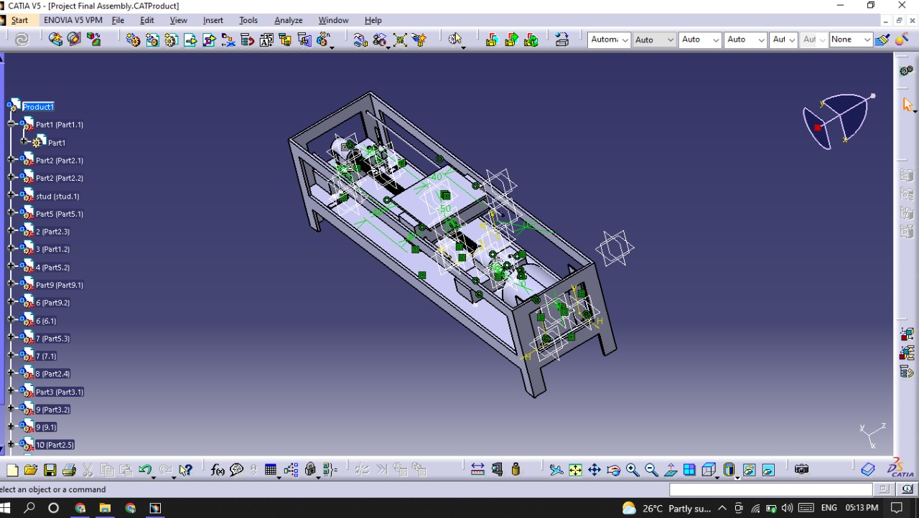

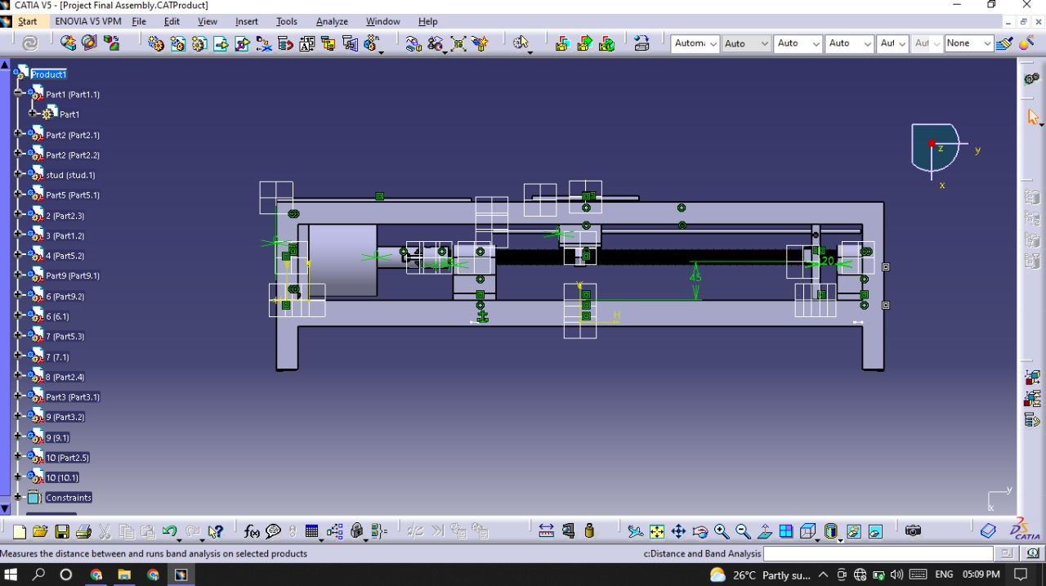

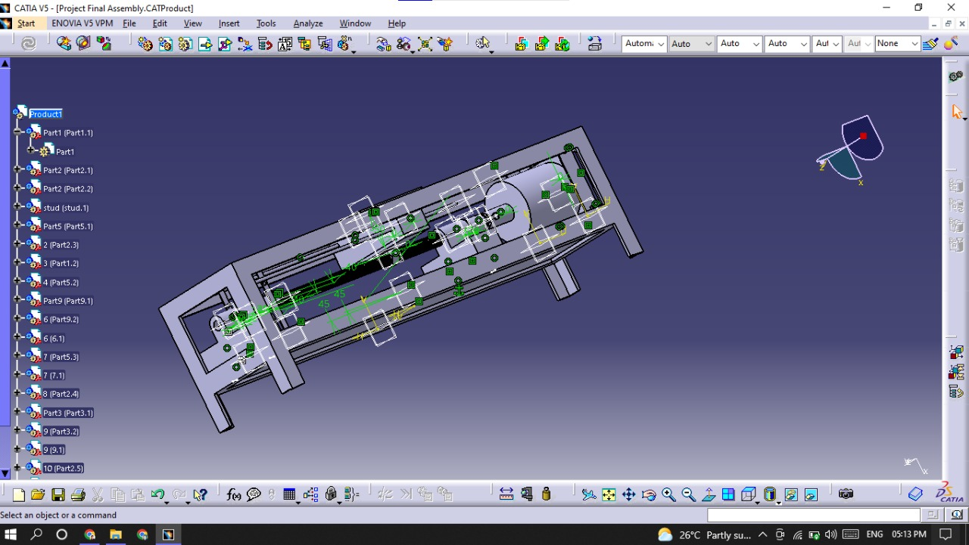

Claims:

1.Sucsessfully manufacturing of 180-degree peel strength measuring machine is done as per design.

2.Readings given by machine is nearly equal to minimum standard given by manufacturer.

3.Maintaince of peel strength measuring machine is low and provide high accuracy with ease in handling.

4. Cost reduction is almost 60 to 70 % for same peel tester and faster in working.